Period 3 (1754 – 1800) Review Sheet
Chapters 5 – 8of the America’s History Textbook

Welcome to Period 3! This period accounts for roughly 12% of the exam. In past exams, this period has been a popular choice for essays and Short Answer Questions, so make sure you are able to explain main ideas!

Potential Short Answer Questions/Essay Topics Include:
- Reasons for the Growth of the First Party System.
- Analyzing the 7 Years’ War as a turning point
- Comparing and Contrasting the Articles of Confederation and the Constitution

Why were these years chosen for this period?

1754 marked the beginning of the 7 Years War (French and Indian) which the British would win and end its longstanding policy of salutary neglect. 1800 marked the election of Thomas Jefferson, which some historians have called The Revolution of 1800.

Key vocabulary terms to know for this time period:

Impact of the 7 Years’ War - France was removed from North America; Great Britain was in massive debt, began to consolidate control over colonies - taxes; many colonists resisted
Common Sense - Written by T-Paine, and Enlightenment thinker. Urged that it was "Common Sense" that colonies should break away from Great Britain
Declaration of Independence - Inspired by Common Sense and Enlightenment ideals; inspired France and countries in Latin America to experience revolutions
Reasons for Patriot Victory in the Revolutionary War - Colonists' familiarity with the land; political and military leadership (Washington); ideological commitment (Natural Rights); Support from European Allies (France after Saratoga)
Northwest Land Ordinance - Passed under Articles - banned slavery in NW territory (OH, MI, IN, etc.); created a process for admitting new states (60,000 inhabitants)
Articles of Confederation - First governing document of US - created a WEAK central government; issues with trade - different currencies in each state, tariffs on goods traded between states
Constitution - Replaced the Articles - series of compromises (Great, 3/5, Slave Trade); provided limits on federal power (separation of powers); did not address problems of slavery
Washington’s Farewell Address - Warned of entangling foreign alliances and political parties; helped inspire foreign policy until after WWII
Republican Motherhood - Expectation that women would instill Republican values in children and be active in families; helped increase education for women
Bill of Rights - Added AFTER the Constitutional Convention; created to gain support of anti-Federalists; guaranteed rights of individuals

https://www.youtube.com/watch?v=N6kTPbwyNWA

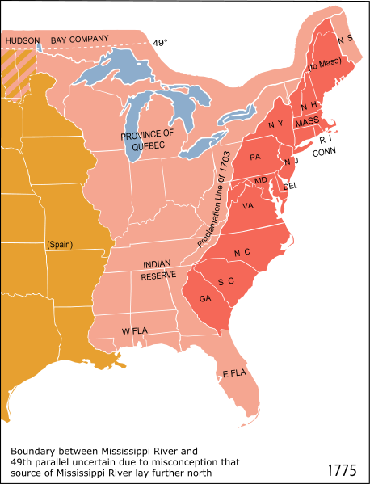
1. What four major events occurred in 1763? Think PEEP. (Check out THIS video for a quick recap of those four events).

2. How did the 7 Years’ War impact the French?

3. Identify and define three examples of salutary neglect ending after the 7 Years War.

4. What was the message of T-Paine’s Common Sense?

5. What were three reasons the Patriots were successful in the Revolutionary War?

6. Why was the Articles of Confederation purposely created to be weak?

7. What was the significance of the Northwest Land Ordinance?

8. How can Daniel Shays’ be seen as a contributor to the Constitution?

9. Describe the following compromises that are found in the Constitution. Great Compromise
- 3/5 Compromise
- Slave Trade Compromise

10. What is the purpose of the Bill of Rights? Why were they added to the Constitution?

11. What were 5 parts of Alexander Hamilton’s Financial Plan? Bold the part that was the most controversial.

12. Complete the following table below about the First Party System.
 | Democratic-Republicans | Federalists
Foreign Policy Favored This Country
View of the National Bank (BUS)
Interpretation of the Constitution
People that supported this party were likely to be
Economy should be based on

13. What was the message of Washington’s Farewell Address? Was his advice followed?

14. How did the Alien and Sedition Acts lead to debates over the power of the government?

15. How did Republican Motherhood help define the role of women after the Revolutionary War?

Document Analysis

“And We do hereby strictly forbid, on Pain of our Displeasure, all our loving Subjects from making any Purchases or Settlements whatever…… without our especial leave and Licence for that Purpose first obtained. And We do further strictly enjoin and require all Persons whatever who have either wilfully or inadvertently seated themselves upon any Lands ……. to remove themselves from such Settlements.”
- Proclamation Line of 1763

1. What was the reaction to this document?

2. What was the cause of this document?

3. What were the effects of this document?

4. What was the Purpose of this document?

5. Who is the Intended Audience of this document?

“Small islands, not capable of protecting themselves, are the proper objects for kingdoms to take under their care; but there is something absurd, in supposing a continent to be perpetually governed by an island.”
- Common Sense, 1776

1. What is the Historical Context of the document?

2. Who is the Intended Audience of the document?
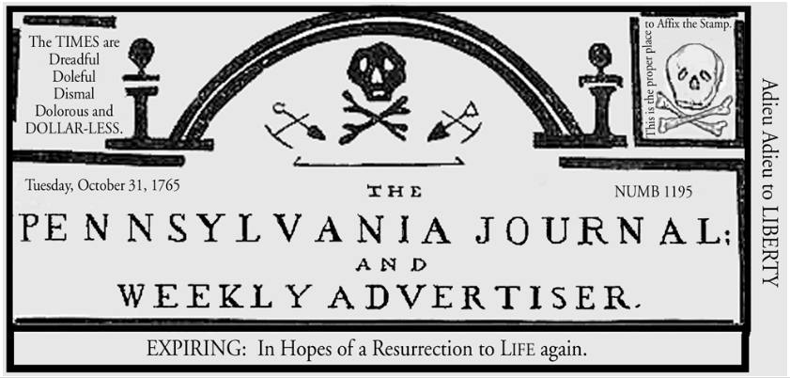
- 1765 Newspaper Masthead

1. What is the Historical Context of this image?

2. What is the Purpose of this image?

3. How did the above image help foster the independence movement?

Only one more document left for this period!
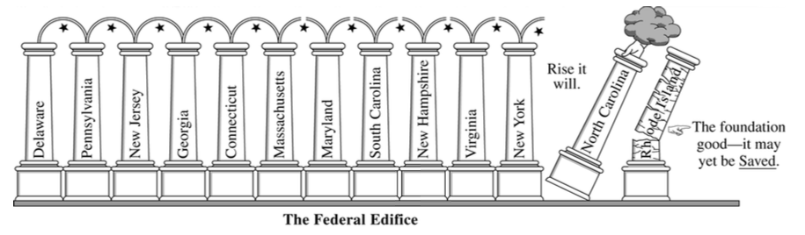

1. What is the Purpose of this image?

2. Who would support this cartoon?

3. Who would oppose this cartoon?

4. Why did people support a stronger government under the Constitution?

5. What, ultimately, led to the ratification of the Constitution?

